I B. Tech - II Semester Idea Creation-1

“ROAD RELIC RENTAL”

Department of DSE-Data Science
By
S. Anusha - 2411CS030421
P. Atrinadh - 2411CS030371
Ch. Rakesh - 2411CS030391
S. Shiva - 2411CS030427
P. Rithwika - 2411CS030381

Under the Esteemed Guidance of
Mr. Sathyanarayana
Assistant Professor – DSE


Malla Reddy University
Maisammaguda, Kompally, Hyderabad- 500100,Telangana State.
Telangana State Private Universities Act No. 13 of 2020 & G. O. Ms. No.
14, Higher Education (UE) Department


Department of DSE-Data Science

CERTIFICATE
This is to certify that the Idea Creation report entitled “ROAD RELIC RENTAL” by S. Anusha (2411CS030421), P. Atrinadh (2411CS030371), Ch.Rakesh(2411CS030391), S. Shiva (2411CS030427), P. Rithwika (2411CS030381) DSE-Data Science, Malla Reddy University, Hyderabad was submitted in partial Fulfilment of the requirements for the completion of the course during the academic year 2023-2024, is a Bonafide work carried out under our guidance and supervision.

Internal Guide Idea Creation HOD
Coordinator

Mr. Sathyanarayana Mr. T. A. Joseph Judson Dr . Suman

External Examiner

Acknowledgment
We have been truly blessed to have a wonderful internal guide, Mr. Satyanarayana Assistant Professor, Department of DSE, Malla Reddy University, for guiding us to explore the ramification of our work and we express our sincere gratitude towards him for leading me through the completion of Project.
We would like express our gratitude to Mr. T. A. Joseph Judson, Assistant Professor, Department of CSE, Idea Creation Coordinator, Malla Reddy University, for providing seamless support and right suggestions are given in the development of the application.
We would like to say our special thanks to Dr. Suman, Associate Professor & HOD, I B. Tech, Malla Reddy University, for providing seamless support and right suggestions are given in the development of the application.
We would like to convey our heartfelt gratitude to Mrs. Lakshmi. T. K, in charge HOD & Assistant Professor, Department of CSE, I B .Tech, Malla Reddy University, for providing seamless support and right suggestions in the development of the application.
We would like to express out heartfelt thanks to Dr. V. Dhananjaya Chari, Dean I B. Tech SOE & SOS, Malla Reddy University, for providing us with the conductive environment for carrying out academic schedules and project with ease.
We are grateful to Vice Chancellor, Chancellor and The Management, Malla Reddy University, for providing excellent infrastructure and their visionary thoughts to prepare ourselves industry ready by focusing on new technologies.
Finally, we would like to thank our family members and friends for their moral support and encouragement to achieve goals.
S. Anusha - 2411CS030421
P. Atrinadh - 2411CS030371
Ch. Rakesh - 2411CS030391
S. Shiva - 2411CS030427
P. Rithwika - 2411CS030386

ABSTRACT
Purpose: The goal of this study is to understand consumer renting habits and to pinpoint
the variables that affect customers decisions when choosing car rental and leasing services.
This article's objective is to look into customer preferences for different vehicle types such as
hatchbacks, sedans, SUVs, crossovers, and luxury cars, and to examine their expectations
Regarding rental pricing, service quality, vehicle condition, and convenience.

Design: This study was designed using secondary research methods to gain insights into customer behavior in the car rental industry. Information was gathered from trusted sources such as Google Scholar, journal articles, industry reports, automotive publications, websites, and existing research papers related to consumer preferences in the vehicle rental market.
Findings: According to the results of a study, People prefer well-maintained, branded vehicles with good mileage and strong safety features.Popular brands such as Toyota, Honda, and Ford are often chosen for their reliability, affordable rental rates, and widespread availability.Many users also value digital convenience such as easy booking, real-time GPS tracking, and multiple payment options.

Originality/Value: The car rental and leasing market in India is growing rapidly.It focuses on understanding customer preferences, rental trends, and service expectations. The goal is to align Road Relic Rental’s offerings with what today’s users value most convenience, flexibility, and reliability. This approach helps us enhance the user experience and stay ahead in the growing car rental market.

INDEX
CHAPTER NO. TITLE PAGE NO.
1 Introduction 7-8
1.1 Summary of application 9
1.2 Background of application 10
2 Literature Survey and Existing System 11
2.1 Existing System 12
2.2 Proposed System & Advantages 13
3 Software and Hardware Requirements 14
3.1 Software Requirements 14-15
3.1.1 Java Script 15
3.1.2 MYSQL 15
3.2 Hardware requirements 16
4 Design- algorithm or flow chat 17
4.1 Algorithm 19
4.2 Screen Shot of Application 20
5 Application Code 22

LIST OF FIGURES
FIGURE NO NAME OF THE FIGURE PAGE NO.

Fig-1 Database diagram of ROAD RELIC RENTAL 18
Fig-2 System Architecture of ROAD RELIC RENTAL 19
Fig-3 Login Page 21
Fig-4 Home Page 22

Chapter - 1
INTRODUCTION
In today's fast-paced world, the thrill of exploring new destinations and uncovering hidden gems has never been more appealing. For adventurers seeking freedom and convenience, Road Relic Rentals steps in to revolutionize the way you experience your journeys. Our mission is simple: to connect travel enthusiasts with reliable and stylish vehicles, ensuring every trip is smooth, memorable, and tailored to your needs.
At the heart of Road Relic Rentals is a passion for exploration and adventure. By offering a diverse fleet of vintage and modern vehicles, we provide a unique opportunity to cruise through scenic routes, visit untouched locations, and embrace the open road without the hassle of ownership. Whether it's a weekend getaway or a cross-country journey, we ensure your travel dreams are just a booking away.
But our service goes beyond vehicle rental it's about creating unforgettable experiences. With flexible plans, competitive pricing, and personalized support, Road Relic Rentals takes the stress out of your travel planning. Plus, with sustainability in mind, our eco-conscious initiatives help protect the beauty of the landscapes you're exploring.
For solo travelers, families, or friends chasing wanderlust, Road Relic Rentals is your trusted companion for adventures near and far. Let us pave the way to extraordinary journeys, where every mile brings joy, freedom, and new discoveries.Road Relic Rental is a modern, customer-focused car rental and leasing platform built to deliver convenience, flexibility, and quality service.
Designed with a clean and responsive layout, the website showcases a wide range of vehicles each with detailed specifications, high-resolution images, and dynamic booking options. Whether you're planning a short trip or looking for long-term leasing, Road Relic Rental makes the process seamless.
With integrated features like real-time GPS tracking, structured booking forms, multiple payment options, and support for secure fingerprint verification, the platform goes beyond traditional rental services. Each vehicle listing is designed for easy comparison, and rental rates are clearly displayed for daily, weekly, and monthly plans.
By combining functionality with a user-friendly design, Road Relic Rental aims to make renting a car not just easy, but enjoyable. It's not just about driving — it’s about driving with reliability, clarity, and style.
Road Relic Rental is not just a car rental service — it's a digital gateway to smooth, reliable, and hassle-free journeys. Built with a modern and responsive design, our platform caters to all your transportation needs, from short weekend getaways to long-term leasing solutions. Whether you're traveling solo, with family, or on a business trip, we offer a wide selection of well-maintained vehicles that match your style, budget, and purpose.
Road Relic Rental apart is its customer-first approach. The entire website is structured to provide a smooth experience with detailed car information.You can easily compare rental rates, view specifications, and book your desired vehicle in just a few clicks.
At Road Relic Rental, we believe that every drive should be memorable. That’s why we continue to improve, innovate, and drive forward with our customers in mind.
Smooth rides. Simple bookings. No compromises.

1.1 Summary of Application
Road Relic Rental represents a new wave in car rental and leasing—where digital innovation meets on-the-go lifestyles to deliver a seamless, trustworthy, and user-friendly vehicle rental experience. Designed with today’s urban travelers, professionals, and adventure-seekers in mind, Road Relic Rental offers a dynamic fleet of well-maintained vehicles, ranging from compact hatchbacks to luxury sedans and rugged SUVs—all accessible with just a few clicks.
At the core of the platform is a fast, responsive, and intuitive interface. Whether you're planning a weekend getaway, need a vehicle for a work trip, or exploring long-term leasing options, Road Relic Rental adapts to your schedule and budget. Real-time GPS tracking, flexible booking forms, and multiple secure payment options ensure a smooth and hassle-free journey from start to finish.
But Road Relic Rental goes beyond simple transportation. It’s a platform built on customer trust, safety, and performance. With clear rental terms, detailed vehicle specs, and smart design, the platform empowers users to make informed decisions—putting control in the hands of the traveler. Each rental experience is built with care, reliability, and convenience in mind.
Sustainability and innovation drive our long-term vision. By introducing electric vehicles, promoting eco-driving practices, and integrating smarter route planning, Road Relic Rental is committed to reducing carbon emissions and contributing to a cleaner, greener planet—while still delivering speed, style, and comfort.
In essence, Road Relic Rental is more than just a car rental website—it’s a lifestyle platform built to fuel your freedom, enhance your mobility, and connect you to the road ahead. Wherever you're headed, we’re here to make every mile count.

1.2 Background of App
The idea for Road Relic Rental didn’t come from a conference room or a corporate plan zit was sparked on highways, in parking lots, and during those everyday moments when reliable transportation felt like a luxury. Whether it was students struggling to find affordable cars for weekend trips, professionals needing flexible leases, or families planning last-minute getaways, we saw the same frustration: car rental was either too complicated, too costly, or just not accessible enough.
We knew it was time for a change.
That’s when Road Relic Rental was born—not just as another car booking platform, but as a mobility companion that understands how people move, live, and explore today.
We envisioned more than just a website to rent cars—we set out to build a seamless, smart, and trusted experience, where every car is showcased with clarity, every booking is smooth, and every journey feels like your own.
Road Relic Rental was built to bridge two key gaps:
- The outdated, inconvenient process of booking rental cars that lacked transparency and modern features.
- The absence of a flexible, tech-enabled platform that served students, solo travelers, professionals, and families alike.
Our platform answers these challenges with a clean, responsive interface, real-time availability, secure payment options, and GPS-enabled booking—all wrapped in user-first design. We’ve handpicked every vehicle and feature to reflect what travelers actually need: trust, flexibility, and comfort.
But Road Relic Rental isn’t just about cars—it’s a movement toward empowered travel. A commitment to give users control of their mobility, whether for a quick drive or a month-long lease. It’s where convenience meets innovation and where journeys—short or long—begin with ease.
In every ride booked, every route tracked, and every satisfied user, our purpose drives forward : To move people, simply. Reliably. Relentlessly.

Chapter -2
Literature Survey and Existing Systems

Literature Survey :
Recent research reveals a notable transformation in consumer behavior toward mobile-based transportation solutions, particularly in the car rental and leasing industry. As digital adoption accelerates in India, users now prefer mobile apps and web platforms for booking vehicles, driven by the need for convenience, speed, and flexibility. Studies indicate that more than 70% of urban users opt for digital car rental platforms over traditional methods, seeking features like real-time availability, GPS tracking, transparent pricing, and on-demand support.
A major trend observed in literature is the growing demand for personalized and flexible rental experiences. Customers are increasingly choosing platforms that allow short-term rentals, subscription-based leasing, and customizable packages. With the rise of remote work, staycations, and weekend getaways, users now expect seamless booking flows, easy vehicle access, and smooth return processes—all from the convenience of their smartphones or laptops.
Another significant insight is the shift in consumer priorities from just affordability to reliability, hygiene, vehicle condition, and eco-friendliness. Research shows that users prefer brands that maintain high-quality fleets, offer contactless delivery, and implement sustainable practices such as low-emission vehicles and digital paperwork to reduce carbon footprint. This aligns with the broader movement towards green mobility and responsible travel.
From a technological standpoint, AI-powered features like smart car suggestions, voice-based search, location-aware pricing, and loyalty programs are revolutionizing the car rental ecosystem. Studies emphasize the value of real-time GPS tracking, responsive customer support, and multiple payment gateways in building long-term user trust and satisfaction.
There is also an increasing preference for platforms that support local service providers and regional fleets, creating a more inclusive and community-based rental environment. As travelers and daily commuters look for platforms that reflect reliability and local relevance, businesses like Road Relic Rental are well-positioned to bridge the gap between traditional rental systems and modern consumer expectations.
Overall, the literature supports the idea that a successful car rental eCommerce platform must combine smart technology, customer-centric design, operational transparency, and sustainability all of which form the foundation of Road Relic Rental.
2.1 Existing System
Right now, many people in India use apps like Zoomcar, Revv, Ola Drive, and Myles to rent cars. These apps work well but they offer only basic features like choosing a car, booking it, and making payment. They don’t give a special or personal experience for different types of users.
Some people still rent cars from local agencies, but this often means going to the office in person, calling them to book, and doing a lot of paperwork. This can take a lot of time and is not convenient for busy people.
Many current apps don’t give features like live GPS tracking, custom car filters (like car type, fuel type, automatic/manual), or monthly car leases. People who want luxury cars, eco-friendly options, or long-term rentals often don’t get enough good choices.
Also, most rental apps don’t think much about the environment. They don’t offer electric cars, eco-friendly services, or paperless bookings, even though more people now care about these things.
Some apps also have problems like hidden charges, strict cancellation rules, or no proper support, which can make the experience frustrating.
That’s why there is a need for a better platform like Road Relic Rental—a modern car rental and leasing service that gives users more choices, simple booking, clear pricing, flexible plans, and a great experience, all in one place.

2.2 Proposed system
Road Relic Rental is a modern car rental and leasing ecommerce platform designed to deliver a seamless, user-friendly, and flexible vehicle booking experience. Built to meet the evolving needs of urban travelers, commuters, tourists, and professionals, the system offers a wide range of vehicles for both short-term rentals and long-term leases—all accessible online with just a few clicks.
From browsing available cars to completing secure payments and tracking vehicle location, the platform ensures a smooth and reliable experience. Key features include category-wise vehicle browsing (e.g., SUVs, sedans, electric vehicles), real-time availability, customizable rental durations, and integration of GPS tracking for enhanced safety.
The system is designed with modular architecture, allowing for independent scaling of components like car inventory, user management, analytics, and payment services. This enables smooth performance even during high traffic. Tools such as Google Analytics, server uptime monitoring, and error logging systems are implemented to ensure quick issue detection and resolution.
Future upgrades may include a mobile app version, user reviews, and loyalty programs to improve customer engagement and retention

Advantages :
Customizable Rentals: Users can select cars based on model, fuel type, seating, and booking duration.
Safety & Security: GPS tracking, verified car details, and secure payment options ensure a trusted rental experience.
Eco-Friendly Choices: Inclusion of electric vehicles and digital paperwork to promote green mobility.
Flexible Leasing Options: Ideal for both short weekend trips and long-term corporate leases.

Chapter-3
Software and Hardware Requirements
3.1 Software Requirements
Front End: HTML and CSS will be used to develop the user interface of the application.
Back End: MySQL and Django are used as backend for storing and retrieving data.
Scripting Language: JavaScript is used as scripting language.
Frame Work: Django is used as framework

3.1.1 JAVA SCRIPT
JavaScript is a high-level, versatile, and interpreted programming language primarily used to create interactive and dynamic features on websites and web applications. Originally developed by Netscape in 1995, JavaScript has evolved into one of the core technologies of the web, alongside HTML and CSS. It is supported by all modern web browsers, making it ideal for developing cross-platform and responsive user interfaces.
One of the most powerful aspects of JavaScript is its ability to run directly in the browser without the need for compilation. This allows developers to create rich, real-time user experiences with features like animations, form validations, dynamic content updates, and more. In the context of our grocery app, JavaScript plays a crucial role in enabling smooth page transitions, product filtering, live search suggestions, and interactive elements like wish lists and carts—all essential for delivering a seamless shopping experience.
JavaScript follows an event-driven, functional, and object-oriented programming paradigm, which makes it flexible and easy to work with. With the help of modern libraries and APIs, it enhances the responsiveness and interactivity of web applications. For example, in our app, JavaScript enables features like voice search, pop-up offers, and barcode scanning all without reloading the page. These real-time features greatly improve user engagement and convenience.
Moreover, JavaScript supports asynchronous operations through features like callbacks, promises, and async/await, allowing our grocery app to handle tasks such as fetching product data, checking availability, or processing payments without slowing down the user interface. With continuous improvements in performance through modern engines like V8 (used in Chrome), JavaScript ensures that even large-scale web applications like ours run efficiently and responsively across devices.
3.1.2 MYSQL
MySQL is the world’s most popular open-source database. According to DB- Engines, MySQL ranks as the second-most-popular database, behind Oracle Database. MySQL powers many of the most accessed applications, including Facebook, Twitter, Netflix, Uber, Airbnb, Shopify, and Booking.com Open Source: MySQL is open-source software, which means you can use it for free and also have access to its source code. This makes it popular among developers and organizations looking for a cost-effective database solution.
Relational Database: MySQL is a relational database, which means it organizes data into tables, where each table consists of rows and columns. This structure makes it easy to organize and retrieve data using SQL queries.
SQL Support: MySQL supports SQL, which is a standard language for interacting with relational databases. SQL allows you to perform tasks such as querying data, inserting new records, updating existing records, and deleting records.
Scalability: MySQL is designed to be scalable, meaning it can handle large amounts of data and high traffic loads. It supports features like replication and clustering to help scale your database as your needs grow.
Compatibility: MySQL is compatible with various operating systems, including Windows, Linux, and macOS. It also supports multiple programming languages, making it easy to integrate with different applications and frameworks.

3.2 Hardware Requirements
Processor : An Intel Core i5 processor or higher will provide sufficient processing power for running the application smoothly.
RAM : 16GB of RAM is recommended to ensure optimal performance while running the application.
Hard Disk : A Minimum of 256GB of free storage space is required to install the necessary software and store the files

Chapter – 4
Data Flow Diagrams

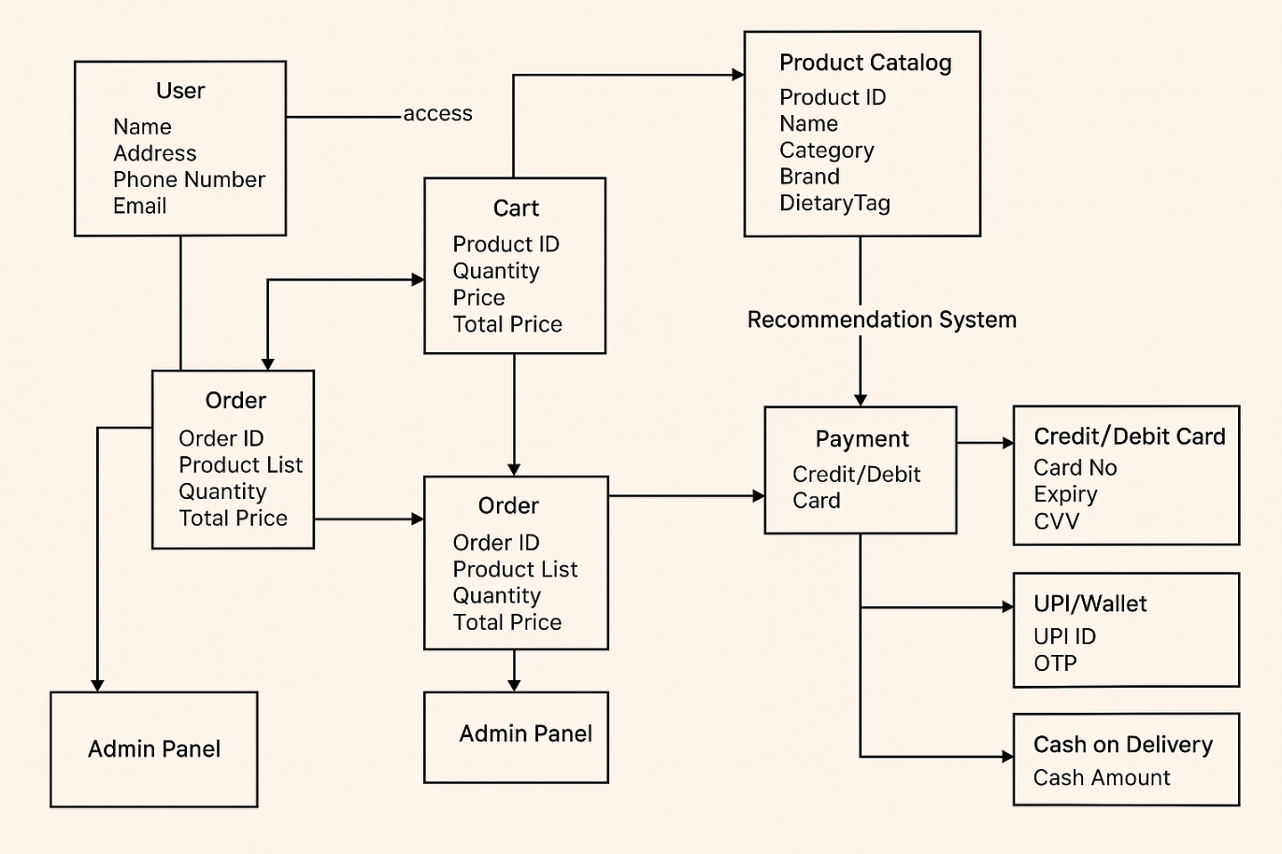
Fig. 1 Database diagram of GIGGLE GOODS
- The user browses the product catalog and selects items to add to the cart.
- After finalizing the cart, the user places an order by providing delivery details.
- The app redirects the user to the payment page with options like Credit/Debit Card, UPI/Wallet, or Cash on Delivery.
- Once payment is completed or marked as COD, the order details are processed.
- The delivery team receives the order for dispatch and delivery.
- The admin panel manages all operations including products, users, orders, and deliveries.
- This ensures a smooth and organized flow from product selection to delivery.

System Architecture

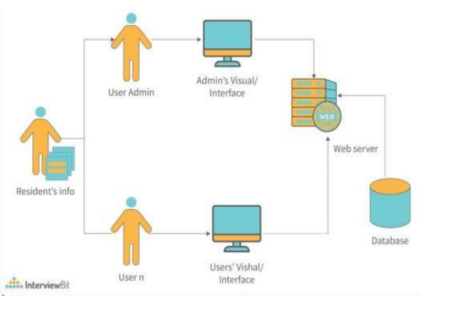

Fig. 2 System Architecture of GIGGLE GOODS
Based on the system architecture diagram provided, it appears that Giggle Goods is a web
based system with an admin interface and a user interface.
The admin interface likely allows administrators to manage user accounts, view resident information stored in the database, and possibly perform other administrative tasks related to the system.
The system architecture includes components such as the web server, which hosts the web
application, and the database, which stores resident information and possibly other data related
to the system's operation.
Overall, Giggle Goods seems to be a platform designed to facilitate online grocery shopping,
With separate interfaces for administrators and users, all accessed through a web-based system.
4.1 Algorithm
1. User registration and login.
2. Browse products by category.
3. Search for specific products.
4. View product details including price and availability.
5. Add products to the cart with desired quantities.
6. Remove products from the cart.
7. Adjust quantities in the cart.
8. Proceed to checkout when ready to purchase.
9. Provide shipping details.
10. Select payment method and complete payment.
11. Track order status from processing to delivery.
12. Receive real-time updates on order location and estimated delivery time.
13. View past orders with details like items purchased and total amount.
14. Receive notifications for order confirmation, status updates, and promotions.
15. Update profile information.
16. Manage payment methods and saved addresses.
This presents the algorithm as a simple list of sequential steps without subheadings. Here's
algorithm for the Giggle Goods application:

4.2 Screenshots of Application

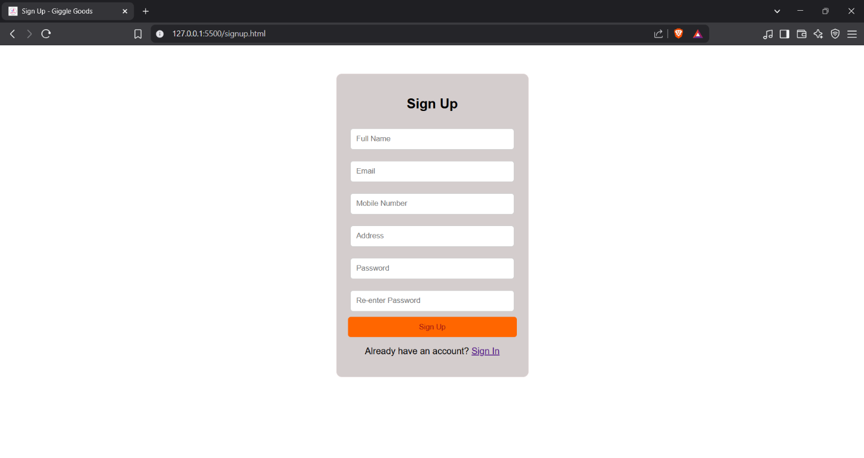
Fig. 3 Login Page
1. The page appears when a user or admin clicks on signup.
2. The User or Admin has to enter their user id and password to get logged in.
3. If you enter wrong , then it will show an error message as “invalid login credentials.
4. If you are a new user then you have to register by clicking signup.

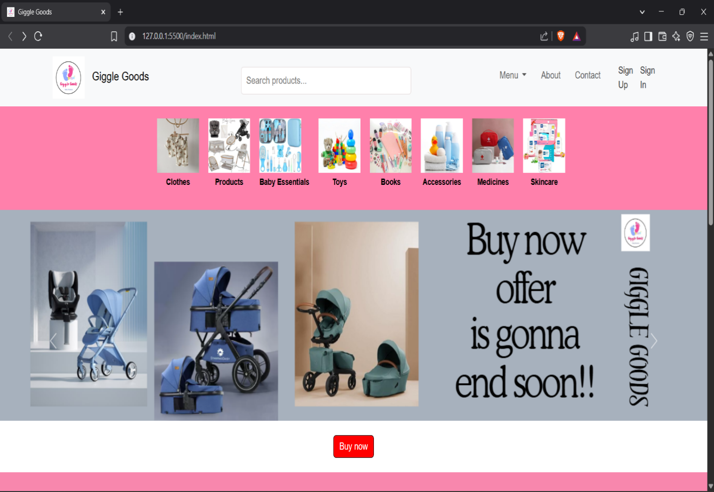
Fig. 4 Home Page
This fig-4 shows the homepage of the Giggle Goods website, an online baby product store. At the top, it features the app's logo, a search bar to find products, and navigation options like Menu, About, Contact, Sign Up, and Sign In. Just below that, there’s a colourful strip displaying product categories such as Clothes, Baby Essentials, Toys, Books, and more with matching images. The main banner area highlights baby strollers with clear images and a catchy offer message saying, “Buy now, offer is going to end soon!!” There’s also a red "Buy now" button to encourage quick action. The design uses soft pastel shades, giving it a cute, modern, and baby-friendly fee

Chapter – 5
Application Code

